**Assignment 2b**

**Problem Statement:** Create Docker Container Environment (NVIDEIA Docker or any other)

**Steps:**

1. **Update the linux OS using following command:**

sudo apt-get update

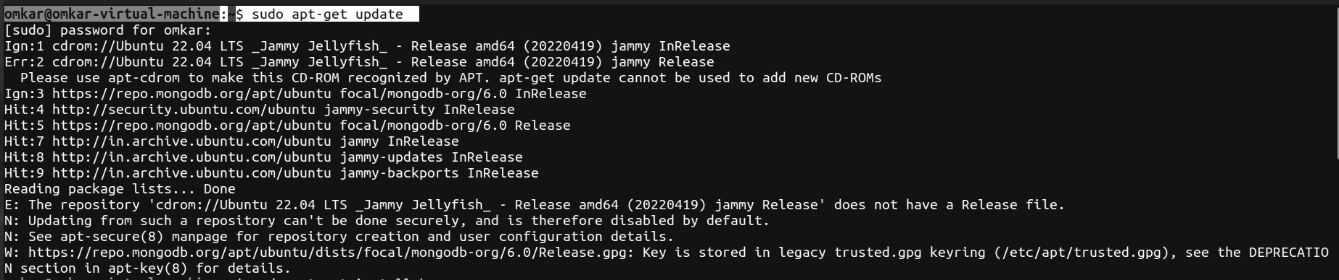

1. **The next step is to install the necessary certificates that will be required to work with the Docker site later on to download the necessary Docker packages. It can be done with the following command:**

sudo apt-get install \

ca-certificates \

curl \

gnupg \

lsb-release

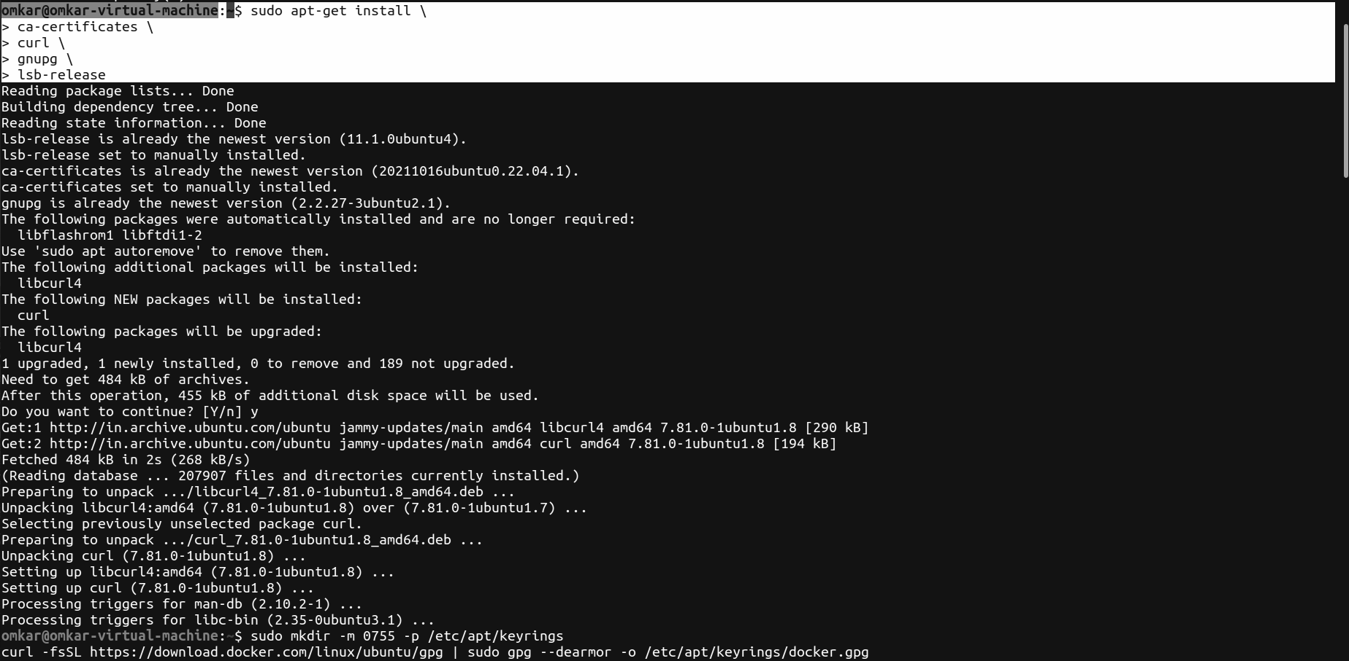

1. **Add dockers official gpg key**

sudo mkdir -m 0755 -p /etc/apt/keyrings

curl -fsSL https://download.docker.com/linux/ubuntu/gpg | sudo gpg --dearmor -o /etc/apt/keyrings/docker.gpg

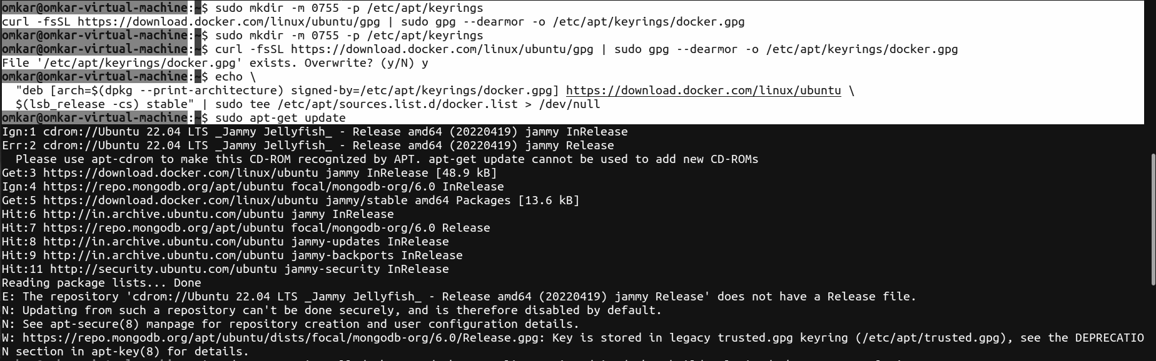

1. **Use following command to set up the repository**

echo \

"deb [arch=$(dpkg --print-architecture) signed-by=/etc/apt/keyrings/docker.gpg] https://download.docker.com/linux/ubuntu \

$(lsb_release -cs) stable" | sudo tee /etc/apt/sources.list.d/docker.list > /dev/null

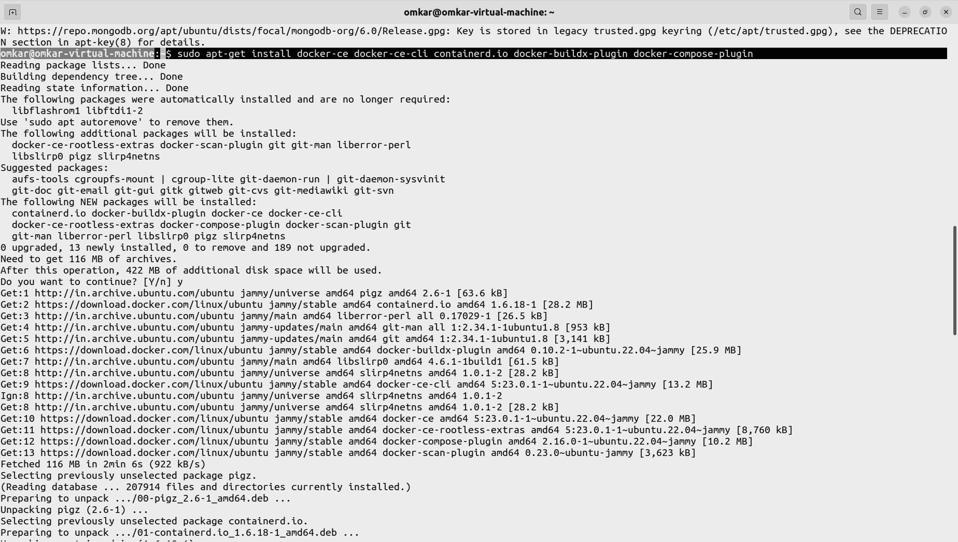

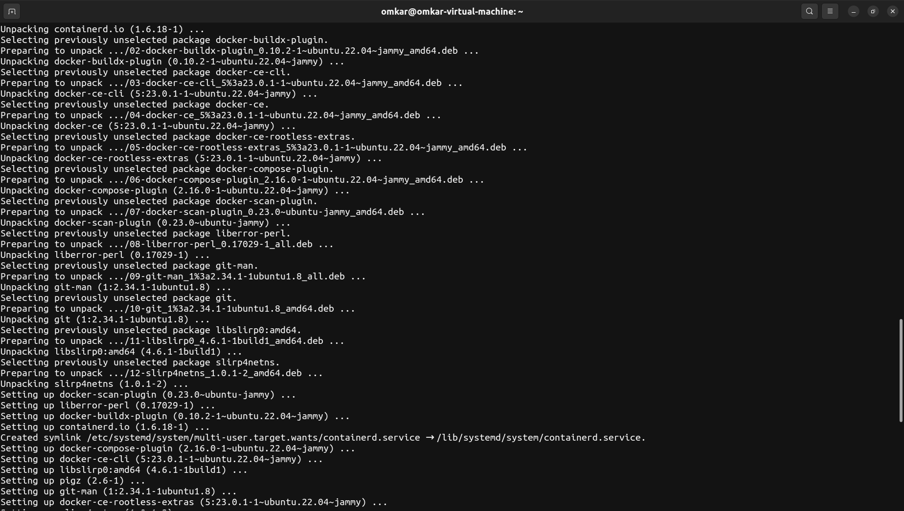

1. **Run the following command to check the installation of Docker container:**

sudo docker run hello-world

